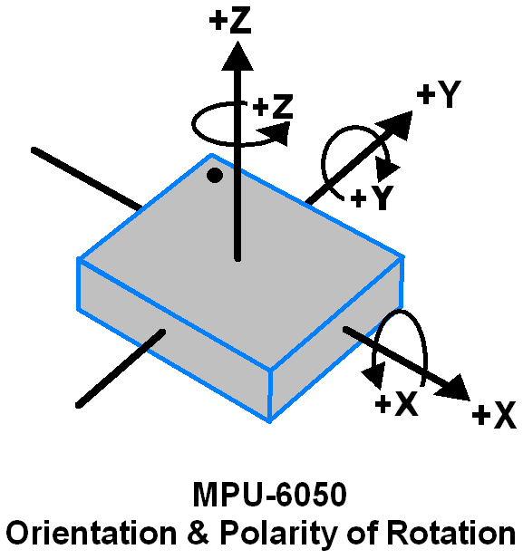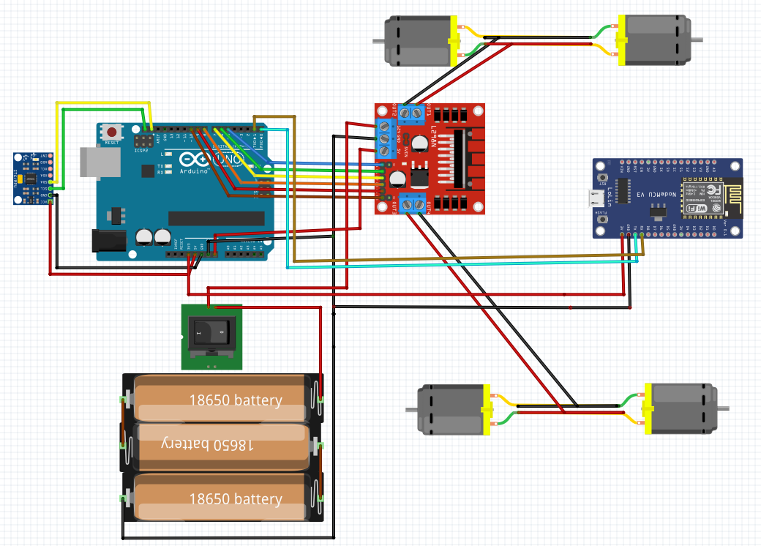

**SELF-DRIVING CAR**

Abdelrahman Shrief

Sondos Reda

Mohamed Alaa

Asmaa Mohamed

Mohamed Hossam

Mahmoud GabAllah

Mohamed Nageh

Moamen Reda